SCHOLARSHIPS
CHINESE GOVERNMENT SCHOLARSHIPS
China welcomes outstanding students and teachers from all countries coming to study or undertaking researches in institutions of higher education in China. The Ministry of Education of China (MOE) is responsible for the provision of Chinese government scholarships, and it entrusts China Scholarship Council (CSC) to administer the recruitment of international students and the routine management of Chinese Government Scholarship students. Chinese Government Scholarships include tuition fees, accommodation, living allowance, insurance, etc. Please consult the website at http://www.csc.edu.cn/Laihua/scholarshiplisten.aspx?cid=97 for further information.

CGS PROGRAMS
CHINESE GOVERNMENT SCHOLARSHIP-BILATERAL PROGRAM
CATEGORIES OF APPLICANTS AND DURATION OF SCHOLARSHIP
The Bilateral Program supports undergraduate students, graduate students, general scholars and senior scholars.
SCHOLARSHIP COVERAGE
The Bilateral Program provides both full scholarships and partial scholarships.
1. Full Scholarship covers tuition waiver, accommodation, stipend and insurance.
2. Partial scholarship covers one or some items of the full scholarship.
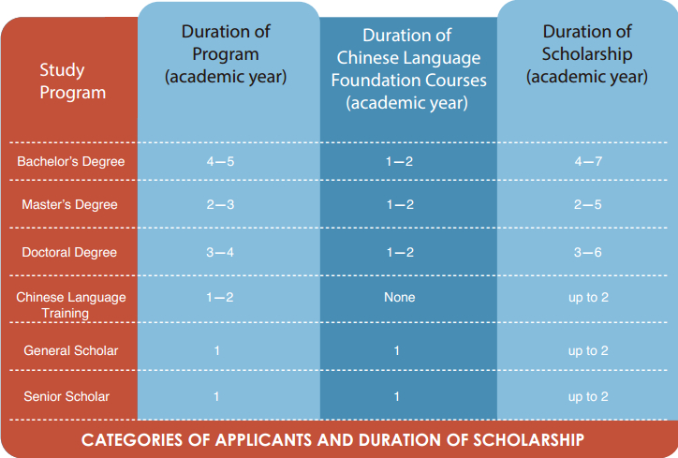
1. According to the regulations stipulated by MOE, all undergraduate programs for international students are instructed in Chinese. Applicants with no command of Chinese are required to take the preparatory courses for one to two years before pursuing major studies. And only by passing the examinations of the preparatory courses could they start their degree studies.
2. UIBE offers some postgraduate programs and non-degree courses for general and senior scholars in English.
3. Scholarship students should complete their study within the set period specified in the Admission Notice which cannot be extended in principle.

APPLICATION
Applicants shall apply to Chinese diplomatic missions or native dispatching authorities between January 1st and April 10th every year. Applicants may contact the above authorities for application details.

CHINESE GOVERNMENT SCHOLARSHIP-CHINESE UNIVERSITY PROGRAM
CATEGORIES OF APPLICANTS AND DURATION OF SCHOLARSHIP
Master’s Degree Students: 2 academic years
Doctoral Degree Students: 4 academic years
SCHOLARSHIP COVERAGE
Full Scholarship covers tuition waiver, accommodation, stipend and insurance.
1. The instruction language could be either Chinese or English. Applicants who apply for courses instructed in Chinese are required to take one year preparatory Chinese language courses prior to the degree study if their Chinese is not qualified. Applicants who apply for master courses instructed in Chinese should pass both Entrance Examination of UIBE and HSK 5 above 220 score, the one who apply for PHD. Instructed in Chinese should pass HSK 6, could they start their degree studies.
2. Scholarship students should complete their study within the set period specified in the Admission Notice which cannot be extended in principle.
3. The scholarship quota is only for the autumn semester of specified academic year.

APPLICATION
Applicants shall send application documents directly to University of International Business and Economics. UIBE shall assess all applications and provide CSC with the nominations for approval. The duration of application starts from January 1st to April 10th each year. The CSC scholarship online application for study in China is available in http://www.csc.edu.cn/Laihua/notice.html.

CGS COOPERATIVE PROGRAM WITH PROVINCES, MUNICIPALITIES AND AUTONOMOUS REGIONS

CATEGORIES OF APPLICANTS AND DURATION OF SCHOLARSHIP
Master’s Degree Students: 2 academic years
Doctoral Degree Students: 4 academic years
SCHOLARSHIP COVERAGE
Full Scholarship covers tuition waiver, accommodation, stipend and insurance.
1. The instruction language could be either Chinese or English. Applicants who apply for courses instructed in Chinese are required to take one year preparatory Chinese language courses prior to the degree study if their Chinese is not qualified. Applicants who apply for master courses instructed in Chinese should pass both Entrance Examination of UIBE and HSK 5 above 220 score, the one who apply for PHD. Instructed in Chinese should pass HSK 6, could they start their degree studies.
2. Scholarship students should complete their study within the set period specified in the Admission Notice which cannot be extended in principle.
3. The scholarship quota is only for the autumn semester of specified academic year.

APPLICATION
Applicants shall send application documents directly to UIBE. UIBE shall assess all applications and provide Beijing Municipal Commission of Education with the nominations for approval. The duration of application starts from January 1st to April 10th each year. The CSC scholarship online application for study in China is available in http://www.csc.edu.cn/Laihua/notice.html.

CONFUCIUS INSTITUTE SCHOLARSHIP
SCHOLARSHIP CATEGORY
Confucius Institute Scholarship provides financial aid for outstanding students of Confucius Institutes (Classrooms), winners of the “Chinese Bridge” Chinese Proficiency Competitions for Foreign College Students and for Foreign High School Students, overseas local Chinese language teachers, outstanding graduates of Chinese language across the world, and outstanding performers on the HSK to study Chinese language for one academic year or one semester in UIBE.
SCHOLARSHIP COVERAGE
Full Scholarship covers tuition waiver, accommodation, stipend and insurance.
APPLICATION
Applicants should log on to the Confucius Institute Scholarship website at http://cis.chinese.cn to get more detailed application information.
Contact:
Program cooperator of UIBE: Ms. Jiang
Tel:86-10-64493598

BEIJING GOVERNMENT SCHOLARSHIP
In order to strengthen mutual understanding and friendship and to develop cooperation and exchange in the fields of education, science, culture and trade between China and the whole world, Beijing Municipal Government has set up a series of scholarships schemes to sponsor international students with tuition fees to study in one of institutions of higher education in Beijing. Applicants may apply for the scholarship through the target university in Beijing.

CATEGORIES OF APPLICANTS AND DURATION OF SCHOLARSHIP
Applicants shall be students who wish to study or are studying in Beijing.
- Excellent international students who pursue degrees at Institutions of Higher Education in Beijing. The duration of the scholarship is no more than 4 academic years.
- Chinese language students and senior scholars. The duration of the scholarship is no more than 1 academic year.
- General scholars. The duration of the scholarship is no more than 1 academic year.
- Exchange students and students with special contributions. The duration of the scholarship is no more than 1 academic year.
SCHOLARSHIP COVERAGE
Beijing Government scholarship covers full tuition waiver or half-tuition waiver.
PLACES OF APPLICATION
- Applicants could consult the Degree program office of SIE, UIBE about application details if you are studying in UIBE.
- Applicants could apply to Admissions Office of School of International Education, UIBE if you graduated in other universities.

APPLICATION PERIOD AND METHOD
- The duration of application starts from January 1st to April 10th of each year.
- Applicants shall obtain the “Application Form for Beijing Government Scholarship” from Admissions Office of School of International Education of UIBE or download the form from UIBE’s website (www.uibe.cn).

UIBE SCHOLARSHIPS
The UIBE scholarships are awarded semi-annually and annually to international students enrolled in the non-degree and degree programs at UIBE who have shown excellence in academic exams, study performance and social/public responsibility. The categories of the prizes established are as follows: prize for excellent freshmen, prize for exceptional studies, prize for study progress, prize for excellent graduates, prize for outstanding student cadres, prize for advanced classes, prize for the activists of social activities, prize for scientific research achievements, prize for scientific research assistance & teaching assistance, and some special prizes.

CONTACT INFORMATION
Admissions Office, School of International Education, University of International Business and Economics
No.10, Huixin Dongjie, Chaoyang District, Beijing, China
Post Code: 100029
Tel: （86-10）6449-2327/2329；（86-10）6449-3419
Fax:（86-10）6449-3820
Email: uibeschorship@163.com sie@uibe.edu.cn
Website: http://www.uibe.cn

